07/08/2025
Lufuno Maiwashe
ST10489459
XHAW5112
Wireframe Design

Jewelleries! Make your world Bling!

Proposal:
- Client’s Needs for the Web page and Mobile APP
Jewelleries is a high-end retail store that offers jewellery pieces, earning, necklaces, bracelets, and watches, their main business goal is to attract customers looking for elegant, timeless, and luxury pieces, both locally and internationally.

To support these goals, jewelleries need:
. A responsive, modern website that showcases their product range with high-quality images and pricing.
. A mobile app to make it easy for on-the-go customers to browse collections, locate stores, and get alerts on promotions or restocks.
. A store locator integrated with Google Map for in-person shopping.
. A booking system for private viewing appointments.
. Clear navigation and luxury-themed branding to maintain trust and sophistication.

- User-Centred Design Approach
We applied a user-centred design process to ensure the final web page and mobile app meet the expectations of actual users. The process included:
- User Research – Inteviews with target users (women aged 25-55, couples, gift buyers) to understand how they shop for jewellery.
- Personas – Created customer personas such as “The Bride-to-be” and “The Luxury Gifter.”
- Prototyping – Low-fidelity wireframes were sketched for early feedback.
- Usability Testing – Testers found the app useful for booking and loved the gallery filtering feature.
- Refinement – Based on feedback, we made homepage similar, improved mobile navigation, and made the product filters more visible.
This process ensured that our design is not only elegant but also practical, inclusive, and easy to navigate.

- Wireframes for Web Page and Mobile App:
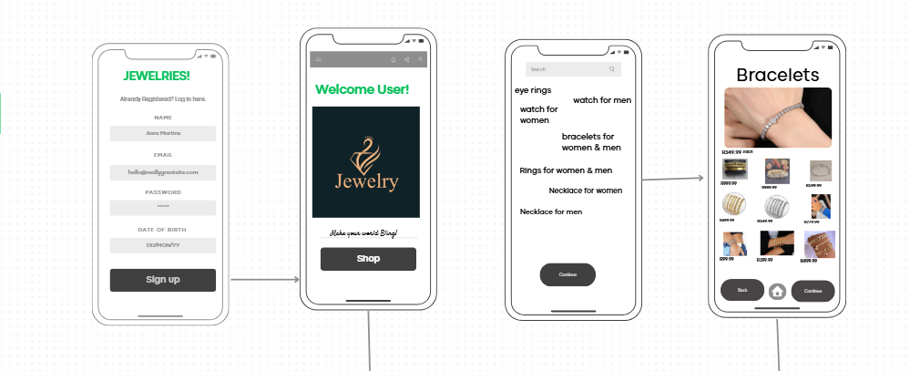
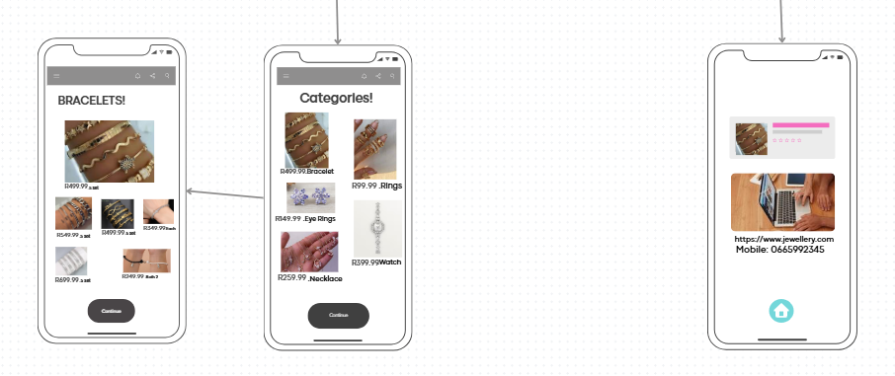

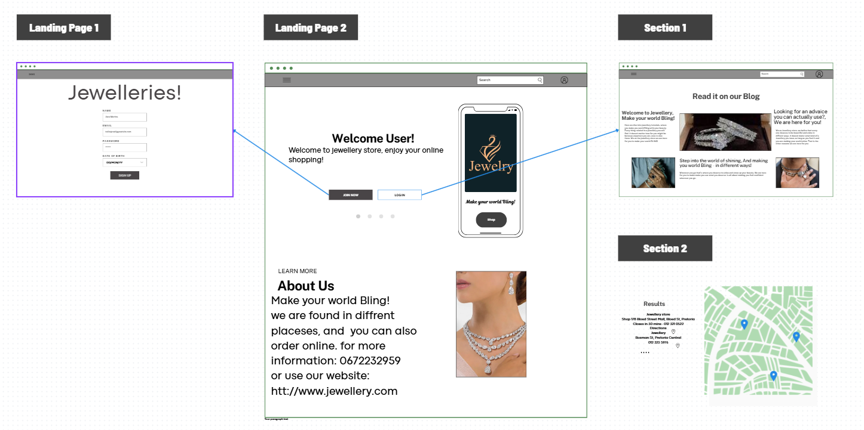

- Logo Design:



